

# World-wide Computer Education 1st semester

**Sportify**

|  |  |
| --- | --- |
| **Project Title** | **Sportify** |
| **Mentor** | **SIR WAQAS** |

# Acknowledgment

**We are Thankful to ALMIGHTY ALLAH that by HIS Grace we have been successful.**

**We are presenting our Project we have tried our best to take all relevant and necessary topics into our consideration so that this project may become**

**comprehensive. This is our 1st Semester. We have strived for a better outlook to come. This project has been developed in Visual Studio Code using HTML,CSS,JS. We have been assigned to make a website namely as our CPISM Project. We tried to observe the coding and its layout in Visual Studio Code. We find it easy to utilize the editor. We would like to thank SIR WAQAS for his guidance and for giving us time from their busy schedule. We also express our sincere gratitude to E-Project team from**

**APTECH CLIFTON CENTER, for their valuable guidance and support for the**

**completion of this project. We earnestly hope that this project will provide all the necessary information required by the user to fulfill his/her inspiration. However, suggestion and feedbacks for improvements will be thankfully welcomed &**

**acknowledged.**

**Introduction To SPORTIFY**

**Problem Statement**

# Sportify

  

**About Sportify**  
Sportify is your ultimate destination for everything sports. From football, cricket, basketball, and tennis to athletics, esports, and more.

**Why Choose Sportify?**  
At Sportify, we believe sports unite people. We provide trusted news, inspiring stories, and behind-the-scenes content that celebrates athletes, teams, and passionate fans worldwide.

1. **Requirement Specification**

***sportsinfo.com*** needs to be constructed considering following requirements:

1. Home page with suitable logo.
2. A menu which will include all the functions implemented in the site.
3. The site should provide the information about following sports:
   1. Football
   2. Judo
   3. Tennis
   4. Motorcycle Racing
   5. Volleyball
   6. Golf
   7. Chess
   8. Billiards
   9. Badminton
   10. Swimming
   11. Athletics.

Apart from the above mentioned sports, you may add other sports of your choice.

1. The information about a particular sport should include:
   1. How many players play the game?
   2. Strategy of the game.
   3. Is it a team game?
   4. Rules of the game.
   5. Some important facts about the game (when was the game invented, any special tournament like World cup / Wimbledon is played etc etc).
   6. Statistics/ records.
   7. Also include the images of the players, clicking on which should display the detailed information about that player.
   8. Which all countries play this game?
2. The user should be able to search a particular sport.
3. Maintain the guestbook as an additional feature just to keep information about the users that visited the site. Guestbook information includes name, email, date of visit, address, comment about the site, whether visitor will recommend the site to others or not etc. Also ask the visitor to rate the site (rating levels 1-Excellent, 2-Good, 3-Average, 4-Poor).
4. Provide a ‘About Us’ page which will introduce the company.
5. There should be a “Contact Us” page which will have the Address of the Company and the mail address which when clicked will invoke the local mail client from where they can send an email.
6. The site should have appropriate look and feel suitable to company’s reputation and status.

**HOME PAGE**

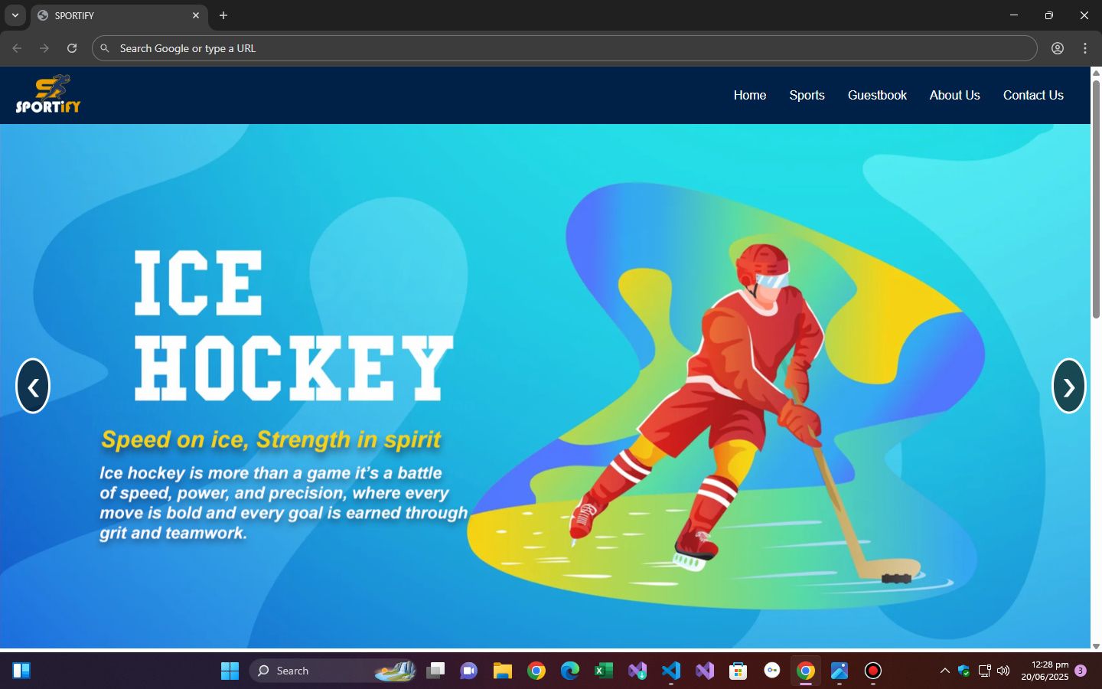

**SPORTS PAGE**

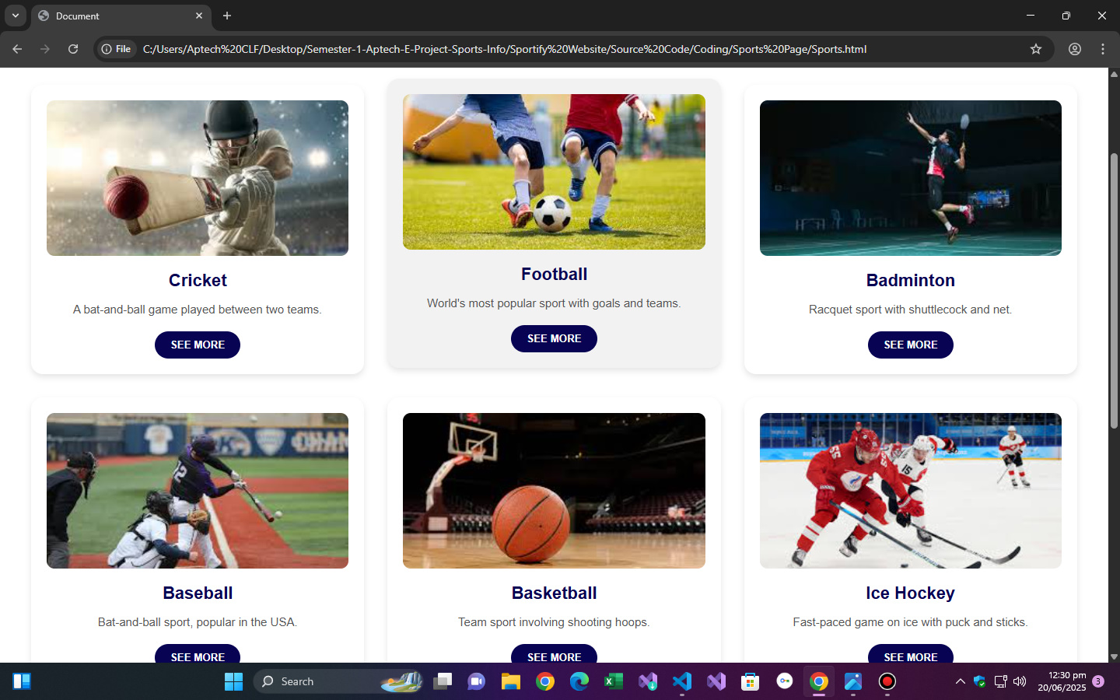

**GUEST BOOK**

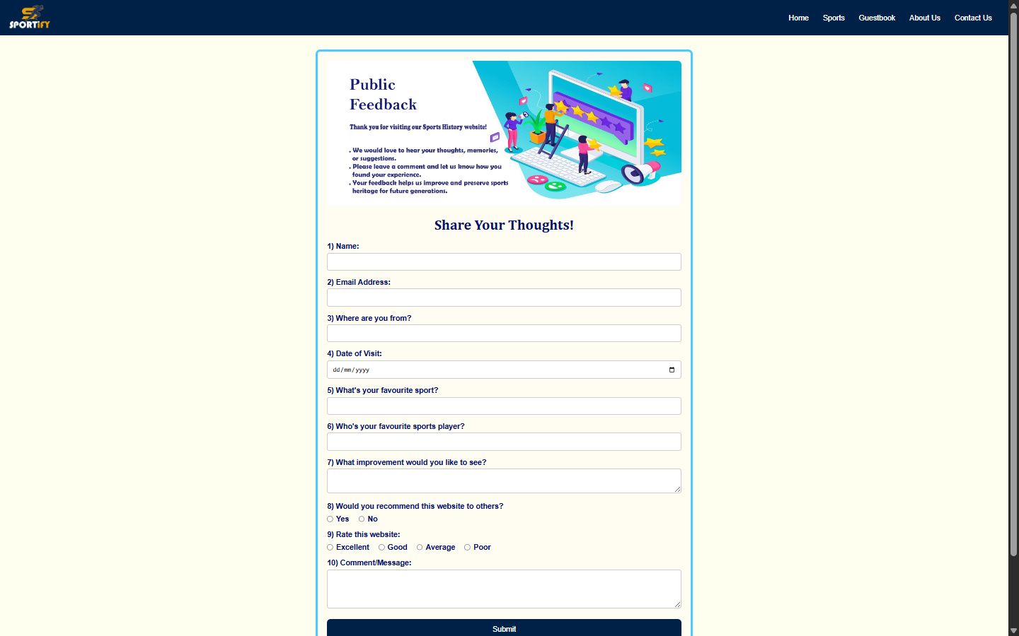

**ABOUT US PAGE**

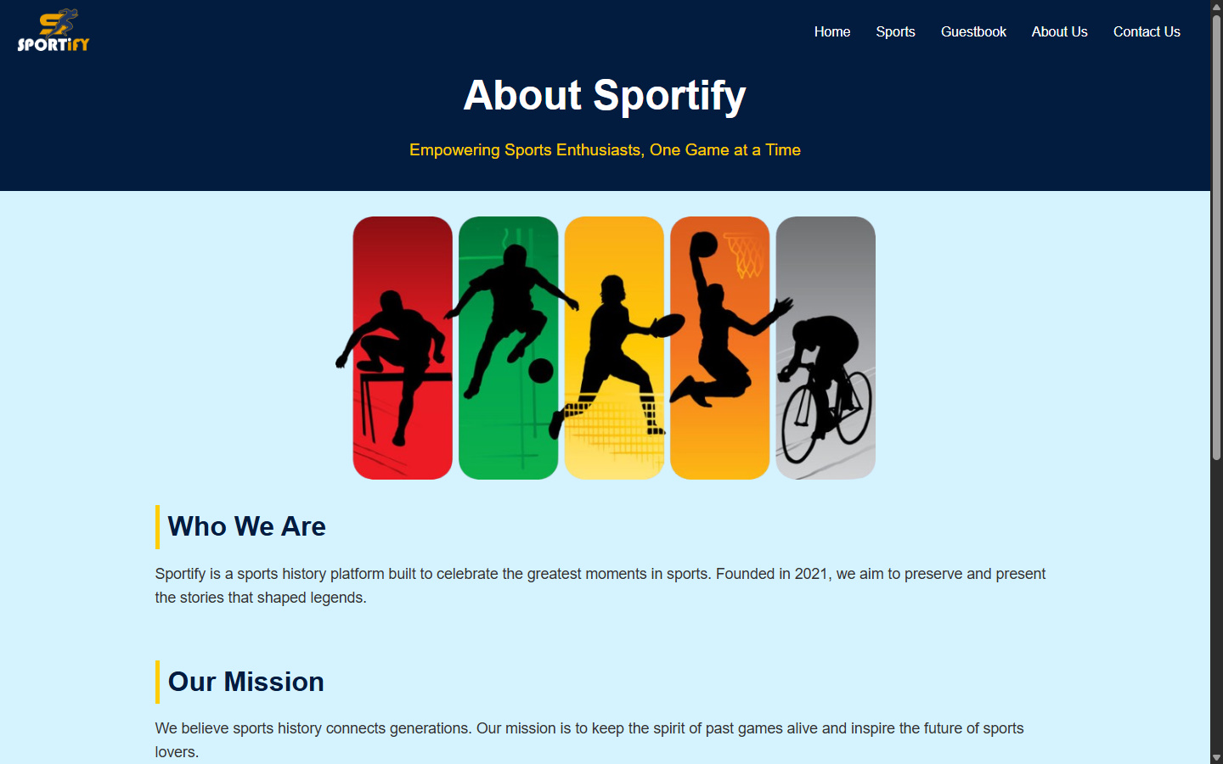

**CONTACT US PAGE**

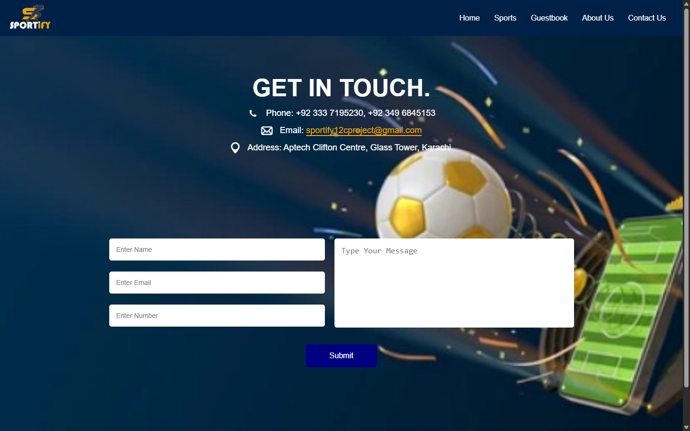

**Coding**

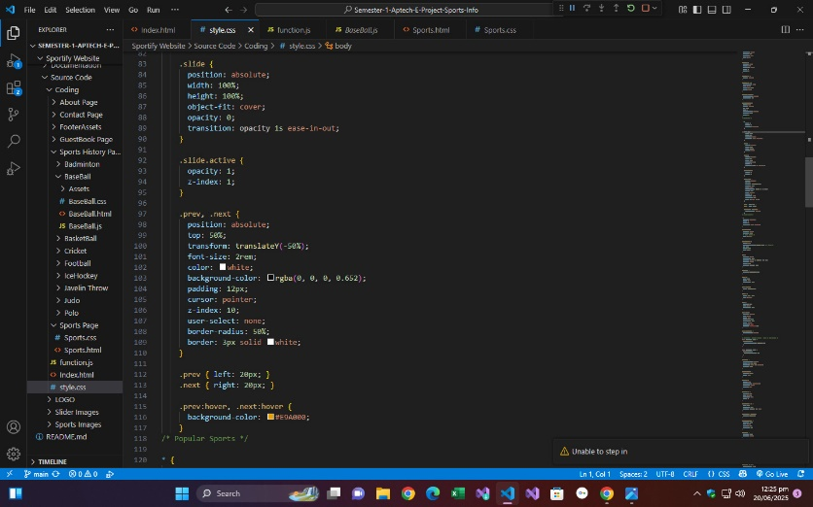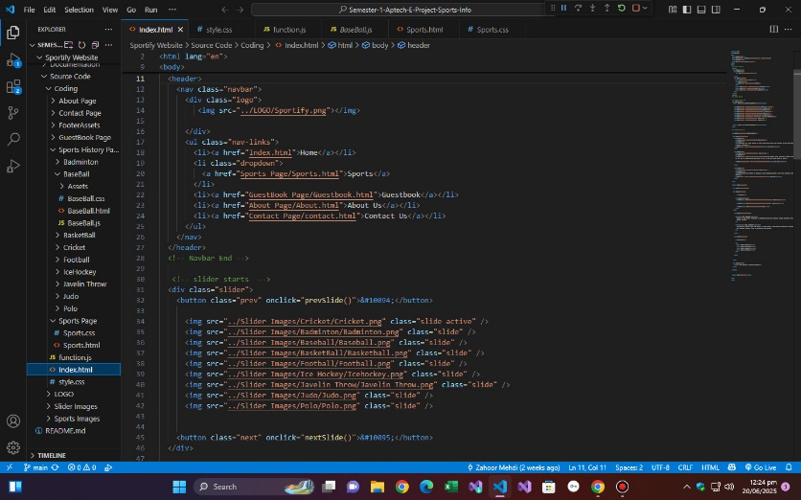

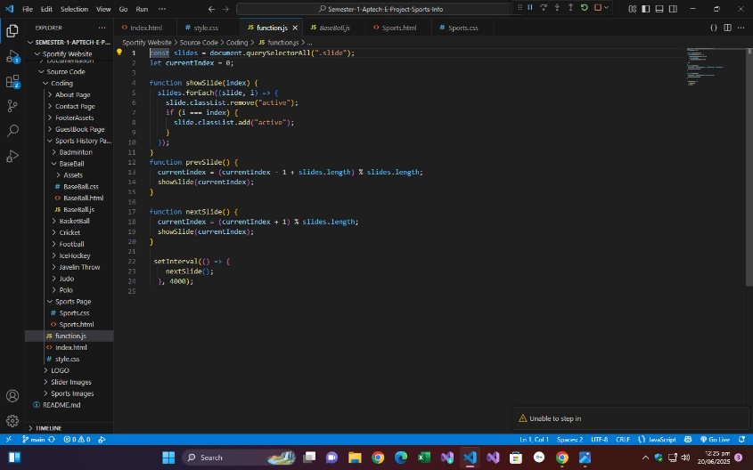

**MEMBERS NAME:**

1. **RIDA NADEEM (GROUP LEADER)**
2. **ANSH KUMAAR**
3. **NAEEM**
4. **ZAHOOR**
5. **UBAID**
6. **MUSKAAN IRFAN**

**THANKS FOR WATCHING**